19th Congress of the Asian College of Psychosomatic Medicine

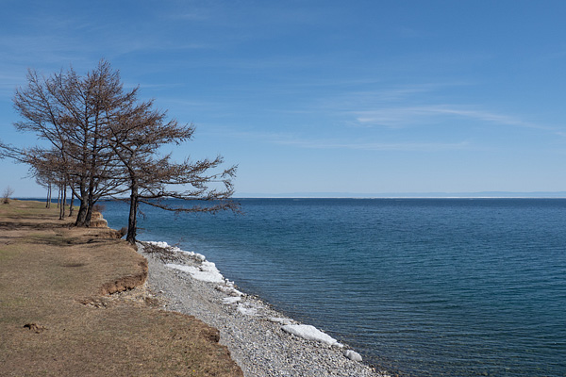
Dear colleagues, on behalf of the Baikal Psychosomatic Association we have the honor to invite all of you to join the 19th Congress of the ACPM (Asian College of Psychosomatic Medicine) in Irkutsk, Russia on august 27–28, 2020. After 1 Congress, in Japan, 1984, the owners of the congress became Korea, India, Australia, China, Taiwan, Mongolia. In 2020 the honor of being the organizers of the congress went to Russia, Siberia, Irkutsk.
Traditionally, every conference has been successful, gathering the representatives of various national schools and directions, professionals in the medical and health field. At the 19th Congress of the ACPM 2019, impressive invited lectures and concurrent sessions will deal with a variety of topics for main theme during three days. We believe that the congress will promote the unification of specialists for the generation and dissemination of new ideas in the field of psychosomatic medicine. We believe this conference will be a great platform to connect the colleagues together and the valuable time to share and discuss various ideas and issues on psychosomatic medicine to leap forward psychological care and leadership from health care system. After all, you can attend the Baikal Lake, which is the oldest (25 million years) and deepest (1,642 m) lake in the world. We hope you enjoy the sightseeing of the Baikal Lake, and do recreational activities during your stay in Irkutsk

ORGANISATION COMMITTEE
Conference chairs
Vasilii Sobennikov, Lubov Richkova, Farid Belialov.
Secretaries
Anna Pogodina, Eugene Vinokurov.

CONTACT US
• 664003, Irkutsk, Russia, 16 Timiryazev Street, the Scientific Сentre for Family Health and Human Reproduction Problems.
• baikalpsa@gmail.com.
• +7-3952-207636
Sobennikov Vasilii (+7-914-8797209; e-mail:vsobennikov@gmail.com

